**User Guide**

Getting Started –

To start the application, we need to start the UI and the database. We need Spring Tool Suite (STS) and MySQL to be installed

The first page you see is the Index page which contains several features for the Online Banking System.

Project Structure looks as -

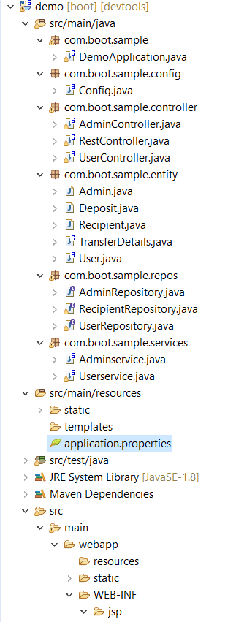 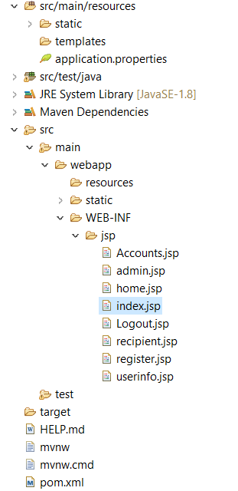

Few details about the structure –

**Com.boot.sample.controller** -This package contains the controller classes for User and Admin. Rest Controller is explicitly written for microservice

**Com.boot.sample.entity** - This package contains all the POJO classes

**Com.boot.sample.repos** – This package contains Interfaces for Admin, Recipient and User extending CRUD Repository respectively

**Com.boot.sample.service** –This package contains Services for User and Admin with business logic

**Application.properties** – This file has DB connection details, path to JSP pages

**Pom.xml –** This file has all dependencies related to Database, web, spring boot, tomcat server etc.

**User Actions**

***Task 1: Register***

* Click the New Registration on the index page
* Fill up all the fields along with the password and submit
* A unique userID will be generated for newly registered users and displayed on the UI. This is like providing Customer id to the new customers

***Task 2: User Login***

* Login with your userID (displayed on the UI while you registered) and password
* Home page will be displayed with
  + Transfer Between Accounts
  + To Someone Else
  + Account Detail Information
  + Add Recipient
  + View Recipient
  + Logout

***Task 3: Transfer Between Accounts***

This allows customer to transfer the amount between his own accounts. It has ‘Home’ button to go back to the Home page. Steps to transfer amount between accounts:

* Select Source Account Type, Destination Account Type
* Enter the amount you want to transfer
* Click Transfer to send the amount

***Task 4: To Someone Else***

This allows customer to transfer the amount to added beneficiary (Recipients). It has ‘Home’ button to go back to the Home page. Steps to transfer amount to recipients in the list:

* Choose the recipient from the dropdown list
* Select the account you would like to transfer from
* Enter the amount you want to transfer
* Click Transfer to send the amount

***Task 5: Account Details Information***

* It displays both Savings and Current account numbers and their respective balances

***Task 6: Update User Profile***

* Logged in User details will be auto populated when clicked on update profile button
* User can update the values and click update
* Profile will be updated

***Task 7: Add Recipient***

This module enables Customers to add the beneficiary details. It has ‘Home’ button to go back to the Home page

Input

* Enter all the required details like First Name, Last Name, Email, Phone Number, Account Type, Account Number
* Click Add button

Output

Recipient would be added successfully, and you can view the recipient list in To Someone Else page while transferring amount

***Task 8: View Recipient***

This section displays all the recipients added for that specific Customer. Each Recipient details can be updated and deleted by the Customer

* Clicking on Edit icon, loads the page with recipient details and Customer can update the details
* Clicking on Delete icon, deletes the recipient and page will be refreshed displaying rest of the recipients.

***Task 9: Logout***

* Clicking on Logout button, invalidates the session and user will be logged out of the application

**Admin Actions**

It is mainly used by Admin. Clicking on ***Admin Login*** from index page, loads the login page for the admin to login with username and password. It involves -

***Task 1: Deposit Amount***

Admin can deposit the amount for the newly registered customers.

Input

* Enter the user id of a customer to whom the amount must be deposited
* Select the account to which the amount must be deposited (Savings or Current)
* Enter the Amount to be deposited

Output  
Amount will be successfully deposited to the specified customer. User can login to check his balance for the deposited amount.

***Task 2: User Information***

Admin can view the Customer’s information

Input

* Enter the user id of a customer to view the details

Output  
Customer’s information like User id, Username, Account Number and Balance are displayed for the specific user

*Open the below file to install all the necessary software and configurations required to run this application*

** **

Open the code and Run the application as – Right Click on the Project and Run as Spring boot app– You will be able to navigate to the mentioned pages.